**Sales Performance Vs Target**

1. Import the Sample – Superstore dataset.
2. Create a visualization with Category and Segment dimensions and Sales measures.
3. Blend the data with the Saved Sample - Sales Target data set to bring in the Sales Target measure.
4. Then Colour code the chart to identify Categories and Segments that are above or below target.
5. For Calculating the below and Above Target Calculation field is created.
6. Add the year of sales to the view to identify trends and outliers.
7. Add a filter so that the user can select one, more than one, or all years.
8. Creating a dashboard with this view.

Calculation of the Above and Below Target

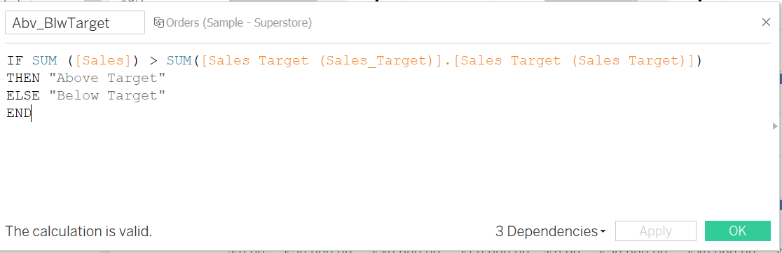

Dashboard for the Sales Performance Vs Target

